Soduckso Requirements Document

***Members***: Julia Kim, John Pesenti

**I. Description**

*Soduckso ™* is a web app that Stevens students (the expected user base) can utilize to get information about the food in Pierce Dinning Hall. The main purpose is to improve the quality of living for Stevens students and faculty and aid in convenience as well as establish an online community for students on campus.

Each page of this web app consists of a navigation bar, linking to the homepage and advanced search page, adding convenience for users trying to use the app. The homepage contains a single search bar where users can search the name of the food they are looking to view the details for. If the food entered exists within the database, that single food item will be returned. (Ex. User enters “quesadillas” and under the search results, “quesadillas” will appear as a hyperlink to the page displaying all the details of the food item “quesadillas”.) The advanced search page is a more general search option that allows for multiple return values. There are on-screen instructions that prompt the user to enter the type of food into the search bar. Upon entering the tag, the site will return all foods related to that entry in a search results list. (Ex. User enters “grill” and under search results, “burgers”, “philly cheesesteak”, “grilled cheese”, “chicken patties”, “fries”, and “grilled chicken” will appear as hyperlinks to the pages displaying all the details of each respective item.)

The scope of the project is to develop each tool the site needs to function (search, database, lists, ect) in a timely manner according to deadlines that will be set in the near future. HTML/CSS and PHP will be the primary languages being used for the actual creation of the site along with supplemental programs such as Violet and Cucumber for planning and project management. Our primary stakeholders include establishments that accept DuckBills, Sodexo, Stevens students, and Stevens employees. The project, once completed would have an impact across Hoboken with a concentration on campus.

**II. UML Use Case Drawings**

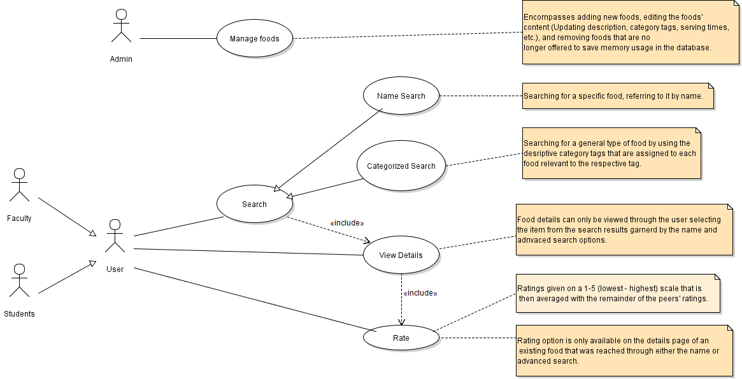

**Purpose:** Improve quality of living for Stevens students and faculty, aid in convenience as well as establish an online community for students on campus

**Scope:** Scopes across Stevens campus and around Hoboken

**Stakeholders:** (potentially) any duckbill accepting establishments, Sodexo, Students, Professors, employees

**Expected Users:** Students, Faculty

**Actors**

Students/faculty (Users)

Administrators

**Use cases**

Administrators

* manage foods (including detail, dates) through the phpmyadmin interface

Users

* rate food
* search for certain foods by name or by tag
* view details about foods

**Prioritizing use cases**

1. Manage foods … must be done first before any other action
2. Search for certain food … must be done after the food is input by the admin
3. View details of food … must be done after searching for and selecting the food
4. Rate food … must first search for an existing food before rating

**Detail**

1. Foods will be entered by an admin who knows the pierce schedule with details including a description of the item along with the times and dates they are being served. The data for these foods (i.e. what is being served and when) will be taken from the Sodexo calendars that can be found on the Stevens website as well as the menus that currently exist in Pierce. Many of the items being listed will be available during all operation hours so the first course of action is to gather the items that are constantly offered (ex. Burgers, fries, pizza, etc.) following with the date/time specific menu items.
2. Each food that is entered into the system will have information on what it is, when it is being served, and what categories it falls under. With that information being available, users will be able to access the foods through an advanced category search, or a specific name search.
3. After putting an entry into one of the search options, results should appear under the results list. Each result will be a hyperlink that when selected, forwards the user to a full list of details describing the food that they selected. The information being displayed will consist of the name of the food, the days and times that food is being served, the relevant categories of that food, and, a brief description of the food, and the food’s community rating.
4. After finding the profile of a particular food, users can rate that food on a scale of 1-5, 1 being virtually inedible and 5 being very good. Users are encouraged to rate the item so that their peers have a more detailed idea of how good that food is. Including a rating system will be beneficial because it is a way for the consumers’ voices to be heard.